Sound of the Heartland
to Highlight Long Tradition at Courtland Covenant Church

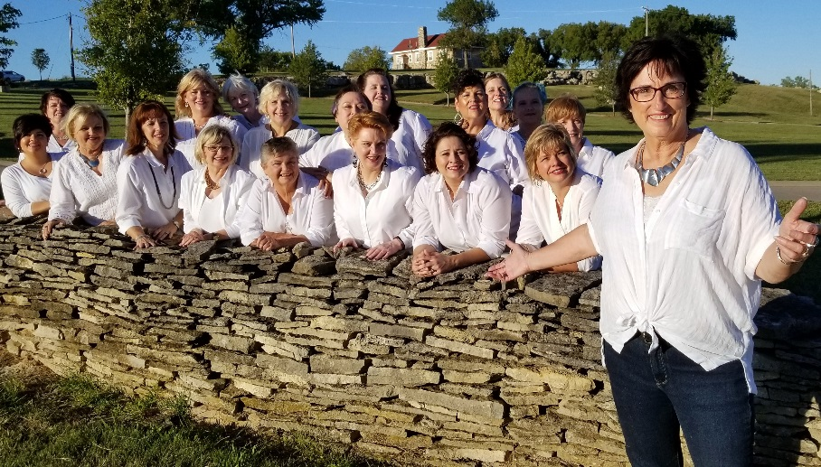

As this church family is blessed year after year, the tradition of thanksgiving and giving back has continued. Offerfest 2018 will be observed on Sunday, November 18 at 4:00 PM. Sound of the Heartland from Newton, Kansas will perform at 4 followed by a thanksgiving meal.
Anyone is invited to the program, if you would like to stay for the meal please contact Julie Lindberg at 785-243-0874 so we can plan accordingly.
Sound of the Heartland, a 22-member women's ensemble based in the Newton/Greater Wichita, KS area. They sing four-part a cappella, the uniquely American Barbershop art form. Their program will feature songs from this year's performance series, "The Fabulous Forties," as well as patriotic and sacred pieces. The goal of each performance is to create an experience their audience will never forget. You can learn more about them on their website soundoftheheartland.com. Check out their website at soundoftheheartland.com!
Offerfest is a decades-long tradition of the Courtland Covenant Church that is observed annually on the Sunday before Thanksgiving.
The original Covenant church was moved into Courtland in 1906 from a location 2 miles east of town. When horses and mules were not able to successfully move the building, a steam engine was brought in to finish the job.
In the late 1950’s, the Covenant Church near Randolph had to be torn down due to the construction of the Tuttle Creek Dam and lumber was transported to Courtland to build this church. Paul Freeman states that a view of the attic shows the superior quality of the wood and the evidence of skillful carpenters; “there is enough lumber up there for two churches!” This new building provided not only the comfort of a modern heating system, but a larger sanctuary and a fellowship room where the congregation could gather to enjoy a cup of coffee or a meal.
The first Offerfest was a celebration of what God had provided: the blessing of a new church building, an abundant harvest and the love of church family. After a bountiful meal and a program, a special offering was taken up to be put into an Improvement Fund for the maintenance of the church and parsonage.

